**CONNECTED HOME ENVIRONMENT MONITORING SYSTEM**

***AN INTERNSHIP REPORT***

***Submitted***

*In the partial fulfillment of the requirements for*

*the award of the degree of*

**Bachelor of Technology in**

**Electronics and Communication Engineering**

By

**N PRUDHVI REDDY**

Reg. No. 141FA05099

Under the guidance of Under the guidance of

Mr. Dhanasudakar Vasudevan Ms. Ashline George

Company Guide Assistant professor



**DEPARTMENT OF ELECTRONICS AND COMMUNICATION ENGINEERING**

**VIGNAN’S FOUNDATION FOR SCIENCE, TECHNOLOGY AND RESEARCH UNIVERSITY**

**VADLAMUDI, GUNTUR – 522 213, INDIA. NAAC ’A’ Accredited**

**May-2018**

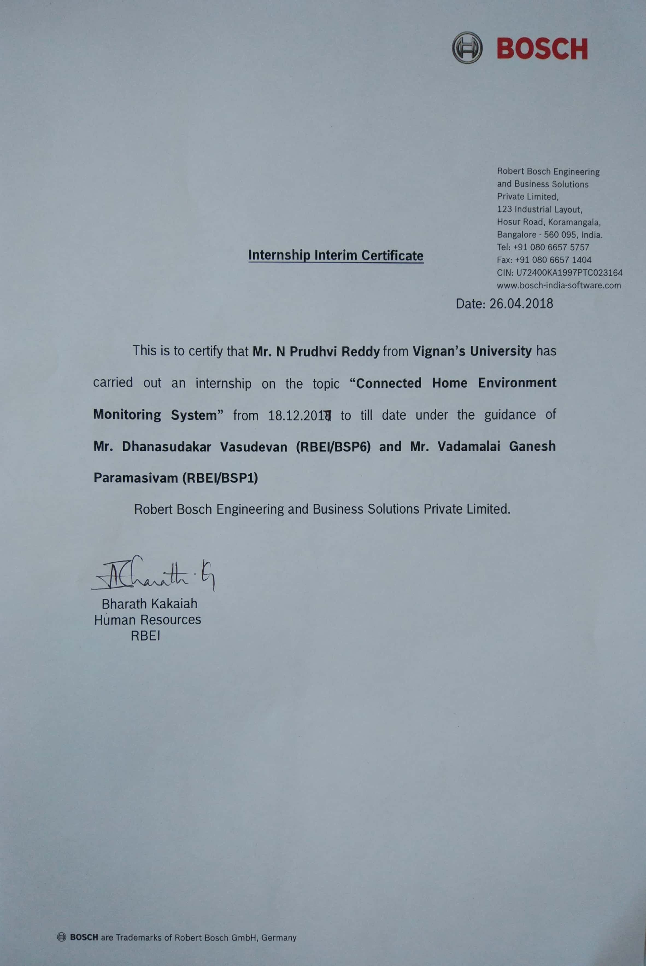

**CERTIFICATE**

This is to certify that the internship report entitled **”CONNECTED HOME ENVIRONMENT MONITORING SYSTEM”** that is being submitted by **N PRUDHVI REDDY** bearing **141FA05099** in partial fulfilment for the award of B.Tech degree in Electronics and Communication Engineering to Vignan’s Foundation for Science Technology and Research University, is a record of bonafide work carried out by them at **Robert Bosch Engineering and Business Solutions Private Limited** under the supervision of **Dhanasudakar Vasudevan** and the internal guidance of **Ashline George** of ECE Department.

Signature of the faculty guide Signature of Head of the Department

Ms. Ashline George Dr. N. Usha Rani Assistant Professor Professor

**DECLARATION**

I hereby declare that the internship work entitled **“CONNECTED HOME ENVIRONMENT MONITORING SYSTEM”** is being submitted to Vignan’s Foundation for Science, Technology and Research, University, in partial fulfillment for the award of B.Tech degree in Electronics and Communication Engineering**.** The work was originally designed and executed by me under the guidance of my supervisor **Dhanasudakar Vasudevan** with **Ashline George** as faculty guide at Department of Electronics and Communication Engineering, Vignan’s Foundation for Science Technology and Research University and was not a duplication of work done by someone else. I hold the responsibility of the originality of the work incorporated into this thesis.

Signature of the candidate

N PRUDHVI REDDY

**ACKNOWLEDGEMENT**

Write briefly about Acknowledge the People whoever helped you in this regard hierarchically.

**N PRUDHVI REDDY**